MORETOWN, VT. Local EmergENCY OPERATIONS PLAN

Emergency Steps
- Establish an Incident Command Structure and make appropriate local decisions
- Delegate Authorities to Incident Commander and request Declaration if appropriate
- Contact State Emergency Operations Center (SEOC) if additional help or resources may be needed beyond mutual aid and local contractors (800-347-0488)
- Alert the general population and evacuate as needed
- Activate your Emergency Operations Center to support the Incident Commander as needed
- Contact the Shelter Coordinator and American Red Cross (800-660-9130) to arrange a shelter opening if needed
- Expand the ICS Structure as needed
- Determine if additional operational shift staffing is needed
- Conduct damage assessment. Report to SEOC
- Conduct and document ‘Emergency Repairs’
Future steps
- Refer to your local codes and standards, Vermont Stream Alterations Rule, and local hazard mitigation plan before undertaking permanent repairs
- If damages result in a Federal Declaration, request 406 mitigation when completing a Project Worksheet
- Conduct an after-action review and develop an improvement plan

Jurisdictions’ Points of Contact: Identify by priority the top three people to be Points of Contact for your Town during an emergency (ex: EMD, Town Manager, Selectboard Chair, Fire Chief)
Job Title | First Name | Last Name | Work # | Radio call sign
Fire Chief & Emergency Coordinator | Stephen | Smith
Email Address | Cell # | Pager # | Home # | Time Contacted
stephen.smith11@yahoo.com | 802-793-2801 |  | 802-496-7562
Job Title | First Name | Last Name | Work # | Radio call sign
Selectboard Chairman | Thomas | Martin | 802-882-8219
Email Address | Cell # | Pager # | Home # | Time Contacted
tjmar106@gmail.com | 802-343-8123 |  | 802-496-2599
Job Title | First Name | Last Name | Work # | Radio call sign
Selectboard member & co-Emergency Coordinator | Michelle | Beard
Email Address | Cell # | Pager # | Home # | Time Contacted
mbeard@gmavt.net | 802-371-7289 |  | 802-496-7758

County: Washington |  |  | Date LEOP adopted: 4/18/16
Name of town EMD/C: Moretown/Thomas Martin |  |  | Date NIMS adopted: 2/22/16
I, the select board chair or town manager, certify that this Local Emergency Operations Plan has been adopted (certifying individual must have taken, at minimum, ICS 402 or ICS 100 training): tjm

Physical Municipal Address: 19 Kaiser Drive, Moretown Vt.
Telephone: 802-882-8219 | Fax: 802-329-2222 | E-mail: mselectboard@moretownvt.net
Alternate communication method: 802-343-8123

This Local Emergency Operations Plan must be adopted annually, after town meeting day, and submitted by May 1st.

Response and Recovery Guidelines
Please use this as an aid for baseline actions that should occur in an incident.
1) Establish an Incident Command Structure and make appropriate local decisions |  |  | Time
a. Identify the Incident Commander
b. Identify the Incident Command Post
c. Start a log of actions taken (see Appendix A3- Activity Log (ICS Form 214))
d. Assess the situation (deploy assessment teams)
 | Determine casualties
 | Determine structure/infrastructure losses
 | Determine resource needs
 | Identify emergency access sites or isolated citizens
e. Request additional resources (Mutual Aid) if needed.
f. Secure a perimeter around affected area if needed
g. Consider potential staffing needs (extended or multiple operational periods)

2) Delegate Authorities to Incident Commander and request Declaration if appropriate |  | Time
Have highest ranking town official delegate authority to and meet with Incident Commander as appropriate (see Appendix D4 – Delegation of Authority)
If needed, the highest ranking town official should sign the Local Jurisdiction Request for Emergency Declaration, and send to DEMHS. (see Appendix A1 – Local Jurisdiction Request for Emergency Declaration)

3) Contact State Emergency Operations Center if additional help or resources may be needed beyond mutual aid and local contractors |  |  | Time
Call State Emergency Operations Center and notify that additional resources may be needed. | 1-800-347-0488
If HAZMAT involved, contact HAZMAT Hotline | 1-800-641-5005

4) Alert the general population and evacuate as needed |  | Time
Alert the Public (including special needs or vulnerable populations) of the hazards of the event at the outset and during the event (including protective actions and evacuation information).
Suggested methods (siren, PA, door-to-door, town website, facebook, twitter, front porch forum)
Complete Planning Task #1 (see page 4)

5) Activate the Emergency Operations Center to support the Incident Commander as needed (See Planning Task #3 on page 5) |  |  |  | Time
Facility Name | Address | Phone Number
Moretown Town Hall | 1147 Route 100B | 802-882-8218
Maintain communications with the SEOC (DisasterLAN, Phone, Fax, Email)

6) Contact the Shelter Coordinator and American Red Cross (800-660-9130) to arrange a shelter opening if needed (See Planning Task #6 on page 6) |  |  |  |  | Time
Notify the American Red Cross that shelters are needed
Contact Shelter Manager
Shelter Name | Physical Address/Location of the Shelter | Shelter Phone # and Manager Name | # of occupants
51764 Harwood Union High School | 458 Vt. Route 100, Duxbury, Vt. | 802-244-5186 Lisa Atwood |  |  | Opened:  Closed:
Moretown Elementary School | 940 Vt. Route 100B, Moretown, Vt. | 802-496-3742 Duane Pierson |  |  | Opened:  Closed:
Moretown Town Hall | 1147 Vt. Route 100B, Moretown, Vt. | 802-343-8123  Tom Martin |  |  | Opened:  Closed:

7) Expand the ICS Structure as needed (see Appendix A3 – Incident Briefing (ICS Form 201))

8) Determine if additional operational shift staffing is needed |  |  | Time
Determine the operational period (8hrs, 12hrs, etc)
Identify staffing for future operational periods (see Appendix A3–Organizational Assignment List (ICS Form 203))
Develop plans for the next operational period (see Appendix A3– Incident Action Plan (ICS Forms 202, 203, 204, 205, 206))
 | What is the Operational Period? hrs to hrs
 | What is the briefing time? hrs
As the incident winds down, release excess resources as per demobilization plans

9) Conduct damage assessment. Report to the State Emergency Operations Center |  | Time
Complete Planning Task #2 (see page 4)
Conduct a complete damage assessment for public and private damages. Submit Local Situation Report to the State Emergency Operations Center (see Appendix A2 – Local Situation Report)

10) Conduct and document ‘Emergency Repairs’ |  | Time
Make roads passable and restore emergency access. Undertake Emergency Protective Measures (eg. removing debris threatening inhabited structures, culverts, and bridges). Emergency Protective Measures (temporary and permanent) must be consistent with the provisions of the Vermont Stream Alterations Rule (see Appendix C2)

11) Refer to your local codes and standards, including the most current Town Road and Bridge Standards as provided by the Agency of Transportation, Vermont Stream Alterations Rule (See Appendix C2), and local hazard mitigation plan before undertaking permanent repairs
Document (photographs, maps, invoices, material quantities) all repairs for future mitigation actions. (ex: roadside/ditch erosion, repair with larger culvert, replace with better materials, etc)
Area Damaged | Cost of repair | Mitigation Solution (see local Hazard Mitigation Plan)

12) If damages result in a Federal Declaration, request 406 mitigation when completing a Project Worksheet.

13) Conduct an after-action review and develop an improvement plan.

PLANNING TASKS
Please complete the white portion of these planning tasks prior to an incident occurring. During the incident, please complete the shaded portions.

Planning Task #1
High Risk Populations List (for special attention/possible evacuation during an incident)
Complete this information before an incident |  |  |  | Complete this information during an incident
High Risk Population Type (school, daycare, nursing home, medical equipment-dependent resident, handicapped resident) | High Risk Population Location  (physical location) | Point of Contact | POC Phone Number | Evacuated To  (physical location) | Time
Elementary School & Preschool Daycare | 840 US Route 100B, Moretown vlg. | Duane Pierson | 802-496-4742
Residents | Moretown village | IC, Steve Smith | 802-793-2801
Riverside Mobile Home Park | 2112 River Road, Moretown | Unsworth Properties | 802-879-4504
Low lying residences | Along the Mad & Winooski Rivers | IC, Steve Smith | 802-793-2801
Eugenie Randall Daycare | 286 Farnham Road, Moretown | E. Randall | 802-585-9049

Planning Task #2
Major High Hazard and/or Vulnerable Sites List (locations to check for damage)
Complete this information before an incident |  | Complete this information during an incident
Site Type: (ex: dam, culvert, bridges, railway crossing, low-lying area) | Site Location  (physical location) | Checked by | Status | Time
Moretown Landfill | 19 Kaiser Drive, Route 2, Moretown, Vt.

* If additional space is needed, please attach information on a separate sheet.

Planning Task #3
Pre-designated Local Emergency Operations Centers
Facility Name | Facility Address  (physical location) | Facility Point of Contact | Facility Phone Number
Primary: Moretown Town Hall | 1147 Route 100B | Tom Martin | 802-343-8123
Secondary: Moretown Fire Station | 1049 Route 100B | Steve Smith | 802-793-2801
Tertiary:

Planning Task #4

Functional Area/ Local Support Function

Please identify agencies responsible for maintaining resource lists, found in Appendix B5.
Local Support Function | Agency Responsible for maintaining resource list:  (see Appendix B5- Resource Lists)
1. Transportation - Assets in support of the movement of emergency resources, including the evacuation of people and distribution of food and supplies. | Highway Department
2. Communications - Includes emergency warning, information and guidance to the public and responders. Includes resources and back-up resources for all means of communication. | Fire Department
3. Public Works & Engineering - Resources in support of debris clearance, road, highway, bridge repairs and restoration of essential public works systems and services and the safety inspection of damaged public buildings. | Highway Department
4. Firefighting - Resources in support of structural and wildfire firefighting. | Fire Department
5. Emergency Management, Recovery & Mitigation - Resources in support of the local Incident Commander through a Local Emergency Operations Center. Includes personnel resources available to provide overall coordination of the town's emergency operations. Resources may serve as a remote ICS planning section to collect, analyze and disseminate critical information on emergency operations for decision making purposes. May provide liaison with state/federal government. | Selectboard
6. Mass Care, Food & Water - Resources available to coordinate sheltering, feeding and first aid for disaster victims. | Selectboard
7. Resource Support - Assets available for coordination and documentation of personnel, equipment, supplies, facilities and services used during disaster response and initial relief operations. | State Police
8. Health & Medical Services - Resources for care and treatment for the ill and injured. Includes lists of trained health and medical personnel and other emergency medical supplies, materials and facilities. Assets include public health and environmental sanitation services, disease and vector control guidelines and resources for the collection, identification, and protection of human remains. | Selectboard
9. Search & Rescue - Resources locally available to locate, identify and remove persons from a stricken area, including those lost or trapped in buildings and other structures. Also includes resources to coordinate S&R for those lost in non-inhabited areas. | State Police
10. Hazardous Materials - Resources available for response, inspection, containment and cleanup of hazardous materials. | Fire Department
11. Agriculture & Natural Resources - Assets available for use in coordinated response in the management and containment of communicable diseases in an animal health or plant emergency | Selectboard
12. Energy - Assets available for the emergency repair and restoration of critical public energy utilities. Includes locally available back-up power resources. Coordinates the rationing and distribution of emergency power and fuel. | Selectboard
13. Law Enforcement - Assets used for the protection of life and property by enforcing laws, orders and regulations. Resources available for area security, traffic and access control. | Constable/State Police
14. Public Information - Pre-identified personnel and resources used for effective collection, control and dissemination of public information to inform the general public of emergency conditions and available assistance. | Selectboard

Planning Task #5
Disaster Lead Agency/Coordinator
Who or what agency will likely be the lead for each type of disaster?
Agency | Drought | Flood | Fire | Winter Storm | Ice Storm | Power Outage | Infectious Disease | Animal/Plant Emergency | Mass Casualty Incident | Hazardous Materials Spill | Public Gathering | Civil Unrest | communications | Other (Please Specify) | Other (Please Specify)
Road Crew / Public Works |  | x |  | x | x |  |  |  |  |  |  |  | x
Fire Department | x | x | x |  | x | x |  | x | x | x |  |  | x
Town Selectboard | x | x | x | x | x | x | x | x | x | x | x | x | x
Law Enforcement |  | x |  |  |  |  |  |  |  |  |  | x
1st Response / Rescue |  |  | x |  |  |  |  |  |  |  |  |  | x
Shelter Coordinator |  |  | x
Animal Control Officer |  |  |  |  |  |  |  | x
Town Health Officer |  |  |  |  |  |  | X |  |  | x
Town Clerk |  |  |  |  |  |  |  |  |  |  |  |  | x
Town Treasurer
Other (Please Specify)
Other (Please Specify)
Other (Please Specify)

Planning Task # 6
Shelters
Shelter 1
 |  |  | 500
Shelter Manager: | Shelter Manager Cell #:  Shelter Manager Pager #: | Other Contact:
Warming Shelter | Overnight Shelter | Red Cross Agreement?
Has a Backup Generator | Has wiring in-place for generator hookup
Shelter 2
Harwood Union High School 458 Route 100S., Duxbury, Vt. Lisa Atwood 802-244-5186 50 | 458 Route 100S., Duxbury, Vt. | Lisa Atwood 802-244-5186 | 500
Shelter Manager: | Shelter Manager Cell #:  Shelter Manager Pager #: | Other Contact:
x Warming Shelter | Overnight Shelter | Red Cross Agreement?
Has a Backup Generator | Has wiring in-place for generator hookup
Shelter 3
Shelter Name: | Physical Address/Location of the Shelter: | Shelter Capacity:
Shelter Manager: | Shelter Manager Cell #:  Shelter Manager Pager #: | Other Contact:
Warming Shelter | Overnight Shelter | Red Cross Agreement?
Has a Backup Generator | Has wiring in-place for generator hookup

American Red Cross – Vermont & the New Hampshire Upper Valley Region: 1-800-660-9130
Burlington Office – (802)660-9130 Rutland Office – (802) 773-9159 Brattleboro Office – (802) 254-2377

Planning Task #7 - NIMS Typed Resources

Type | I | II | III | IV | Other | Type | I | II | III | IV | Other
Critical Incident Stress Management Team |  |  |  | N/A |  | Hydraulic Excavator, Large Mass Excavation |  |  |  | N/A
Mobile Communications Center |  |  |  |  |  | Hydraulic Excavator, Medium Mass Excavation | 1
Mobile Communications Unit |  |  | N/A | N/A |  | Hydraulic Excavator, Compact
All-Terrain Vehicles | N/A | N/A | N/A | N/A |  | Road Sweeper
Marine Vessels | N/A | N/A | N/A | N/A |  | Snow Blower, Loader Mounted
Snowmobile | N/A | N/A | N/A | N/A |  | Track Dozer
Public Safety Dive Team |  |  |  |  |  | Track Loader
SWAT/Tactical Team |  |  |  |  |  | Trailer, Equipment Tag-Trailer | 1 |  |  | N/A
Firefighting Brush Patrol Engine | N/A | N/A | N/A |  |  | Trailer, Dump |  | N/A | N/A | N/A
Fire Engine (Pumper) | 1 |  |  |  |  | Trailer, Small Equipment |  |  | N/A | N/A
Firefighting Crew Transport | 1 |  |  | N/A |  | Truck, On-Road Dump | 3
Aerial Fire Truck |  |  | N/A | N/A |  | Truck, Plow | 1
Foam Tender |  |  | N/A | N/A |  | Truck, Sewer Flusher
Hand Crew |  |  |  |  |  | Truck, Tractor Trailer |  |  |  | N/A
HAZMAT Entry Team |  |  |  | N/A |  | Water Pumps, De-Watering
Engine Strike Team | 1 |  |  |  |  | Water Pumps, Drinking Water Supply - Auxiliary Pump
Water Tender (Tanker) |  |  |  | N/A |  | Water Pumps, Water Distribution
Fire Boat |  |  |  | N/A |  | Water Pumps, Wastewater
Aerial Lift - Articulating Boom |  |  |  |  |  | Water Truck |  | N/A | N/A | N/A
Aerial Lift - Self Propelled, Scissor, Rough Terrain |  |  |  |  |  | Wheel Dozer |  |  | N/A | N/A
Aerial Lift - Telescopic Boom |  |  |  |  |  | Wheel Loader Backhoe
Aerial Lift - Truck Mounted |  |  |  |  |  | Wheel Loader, Large
Air Compressor |  |  |  |  |  | Wheel Loader, Medium | 1
Concrete Cutter/Multi-Processor for Hydraulic Excavator |  |  |  |  |  | Wheel Loader, Small |  |  |  | N/A
Electronic Boards, Arrow |  |  |  |  |  | Wheel Loader, Skid Steer |  |  |  | N/A
Electronic Boards, Variable Message Signs |  |  |  |  |  | Wheel Loader, Telescopic Handler
Floodlights |  |  |  | N/A |  | Wood Chipper |  | N/A | N/A | N/A
Generator | 1 |  |  |  |  | Wood Tub Grinder
Grader | 1 |  |  | N/A

Information about the NIMS Typed resources can be found at: https://rtlt.ptaccenter.org/Public/Combined

Town Maps

Please insert town maps here. These maps can include things such as roads, town boundaries, shelter locations, high hazard/vulnerable sites, etc. 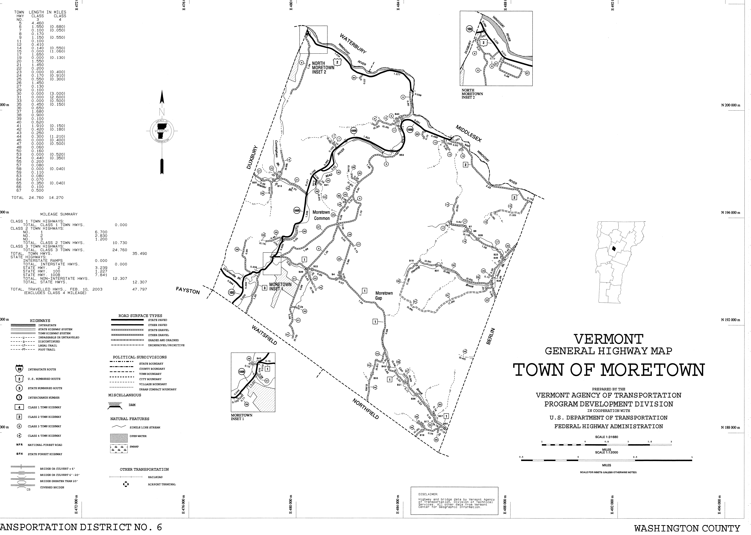

Appendix A – Disaster Forms A

Local Request for Emergency Declaration A1

Local Situation Report A2

ICS Forms A3

Appendix B – Local Documents B

List of Delegations of Authority B1

Communication Plan B2

Emergency Contact List B3

List of Mutual Aid Agreements B4
Resource Lists B5
Maps, Diagrams, Plans, and Attachments B6
CPOD Profile B6.1

Appendix C – References & Authorities C

Emergency Relief and Assistance Fund C1

Vermont Stream Alteration Rule C2

Minimum Grant Standards C3

Vermont Statute Title 20, Chapter 1 C4

NIMS Executive Order C5

Appendix D – Templates D

NIMS Adoption D1

Mutual Aid D2

Emergency Management Ordinance D3

Delegation of Authority D4

Other phone numbers of interest to the town:

Vermont State Police 802-229-9191
Martin Cameron – Road Depart..cell 802-279-9300
Green Mtn. Power 888-835-4672
Waitsfield Telecom 496-3391
Gillespie Fuels 485-3766

Town of Moretown radio frequency 154.19000
Town of Waitsfield radio “ 154-19000

